
Diagnostic exam
Third grade
Name: ……………………………
*******************************************************************
1.Look and circle :(4 marks)

1.Is it a mosque? 2. Is it a pencil case?
- Yes, it is ./ - No ,it isn't. - Yes, it is ./ - No ,it isn't.  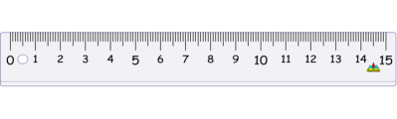
1.Is it a ruler? 2. Is it a rubber?
- Yes, it is ./ - No ,it isn't. - Yes, it is ./ - No ,it isn't. 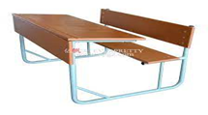 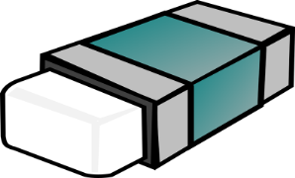

2.Draw flowers (2marks)
four

Eleven

one

Sixteen
3.Look and match :(4 marks)
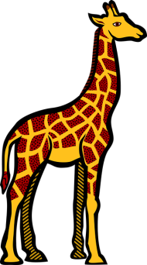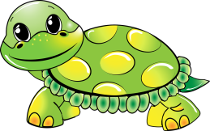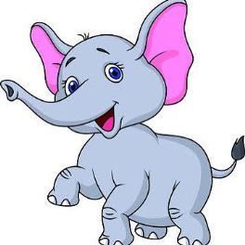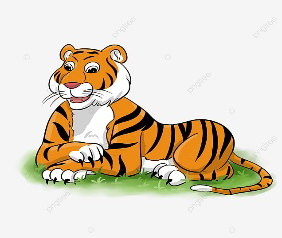

Elephant | Tiger | Giraffe | Turtle

4.Look and write:(4 marks)

Stomachache | Toothache | Earache | Headache

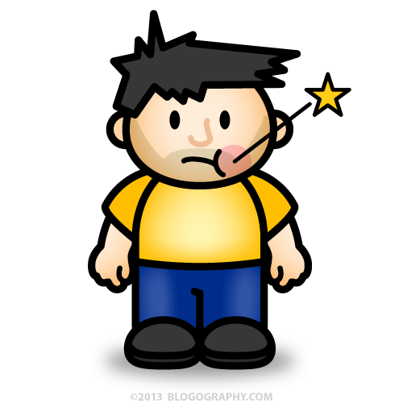

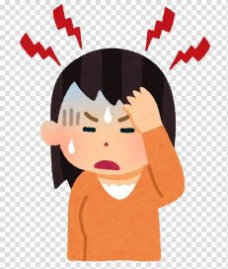

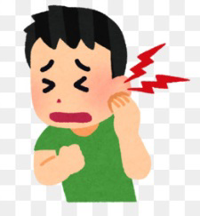

5. Listen and write the letters :(6 marks)

Best wishes

