The Ministry of Education
The Education Directorate of AL-Ramtha
Diagnostic Test- first Term
2022/2023
Class: 2nd Grade (Action Pack 2) Material: English Language
Date:
Time: One hour.
Name: .......................................................................................................................................Section :(..................)
PART ONE
Question One: (2 points)
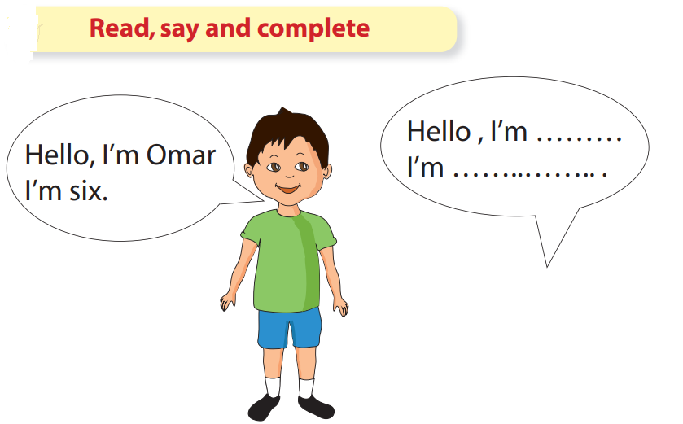

Question Two (5 points)
Count and write

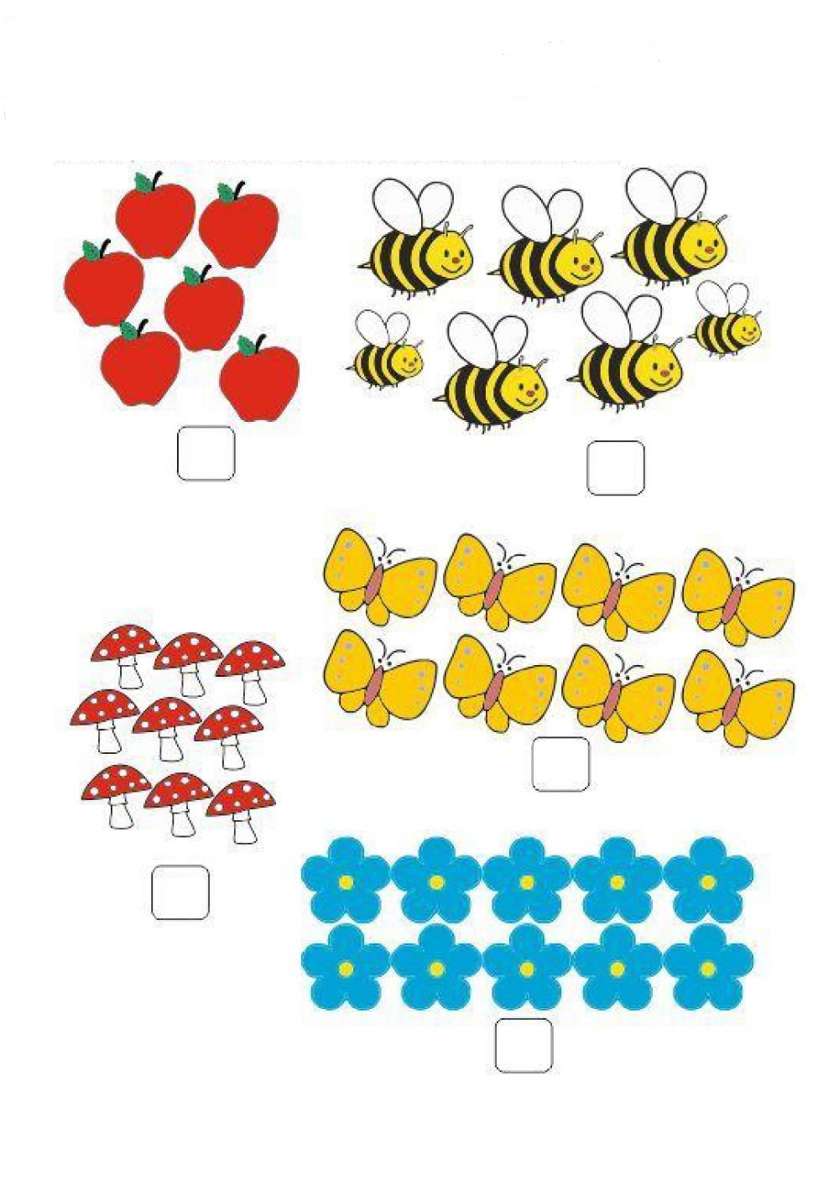

Question Three: (3 points)
Read and match

Table School bag
Doll
Bus
Pencil Sofa
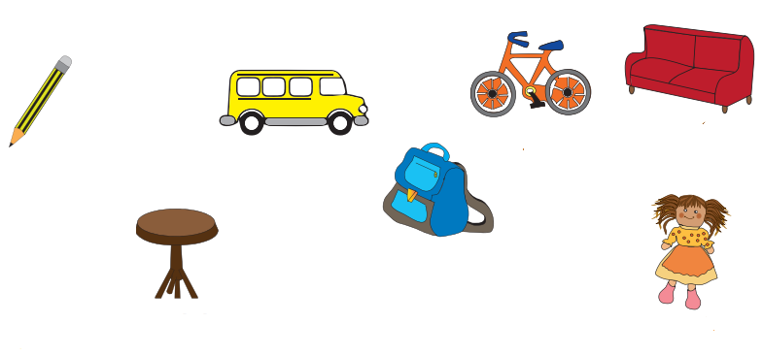

Question Four: (3 points)
Say and color

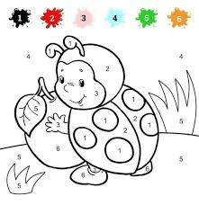
Question Four: ( 3 points)
Say and color

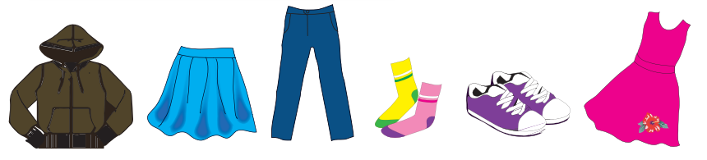

Dress jacket socks
skirt shoes trousers

Question Five: (4 points)
Look and write

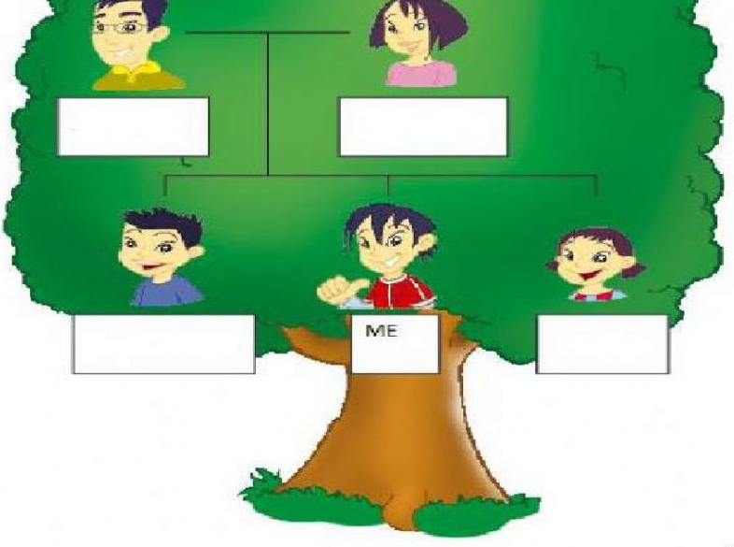
Mum
Brother
Sister
Dad

Question Six : (5 points)
Look and Match

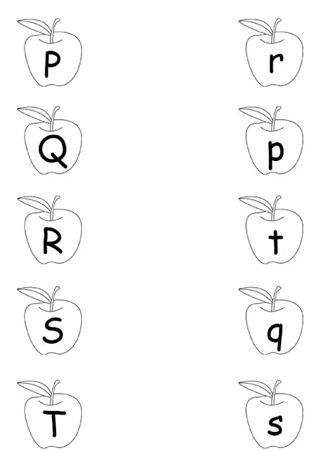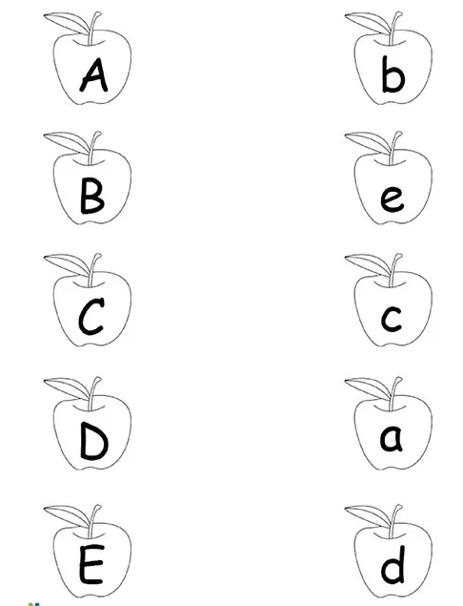

Teacher :Ghada Hamed Ateeq

