The Ministry of Education
The Education Directorate of AL-Qwesmah
Diagnostic Test- first Term
2025/2026
Class: 2nd Grade English Language
Date:
Time: One hour.
Name: .......................................................................................................................................Section :(..................)
PART ONE
Question One: (2 points)
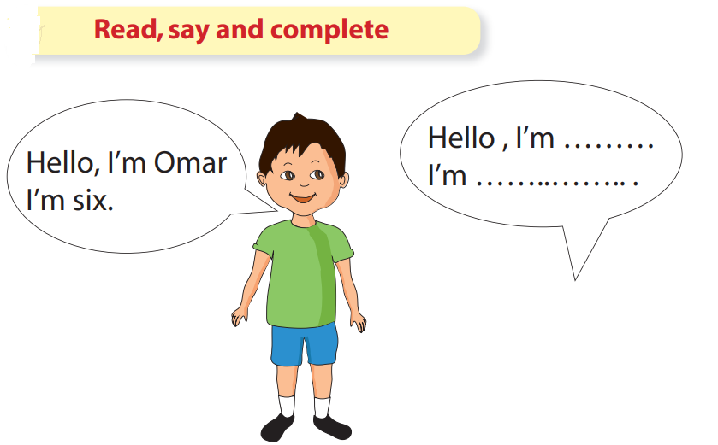

Question Two : (5 points)
Count and write

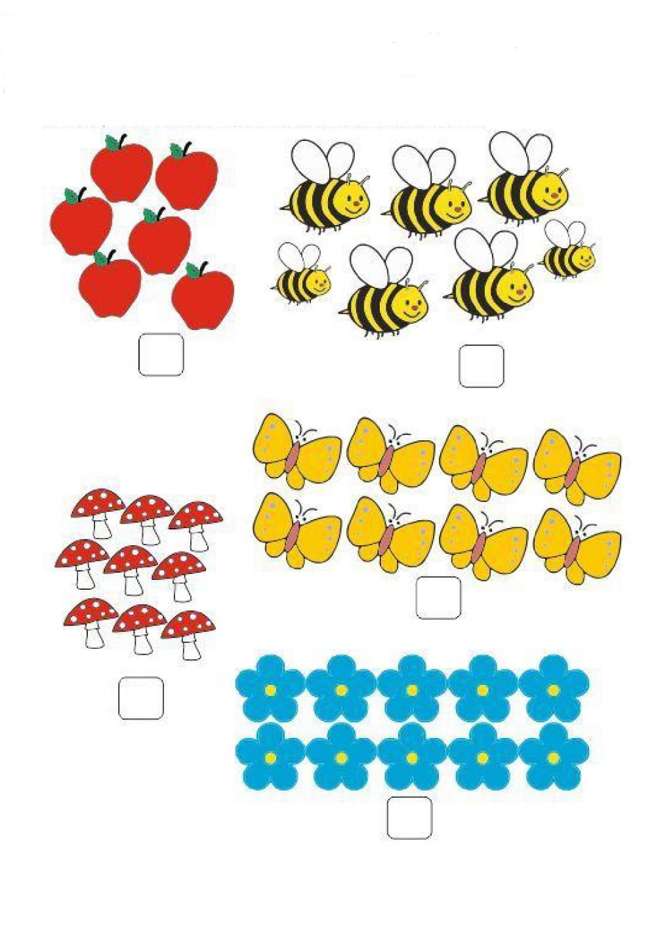See page 2

Question Three: (3 points)
Read and match

Table School bag
Doll
Bus
Pencil Sofa
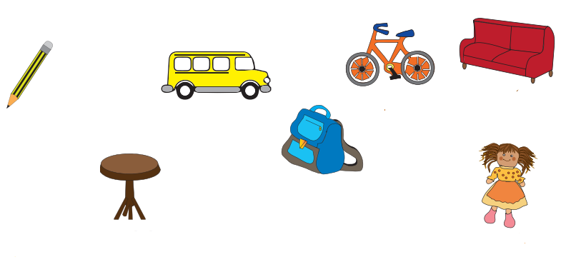

Question Four: (4 points)
Look and write

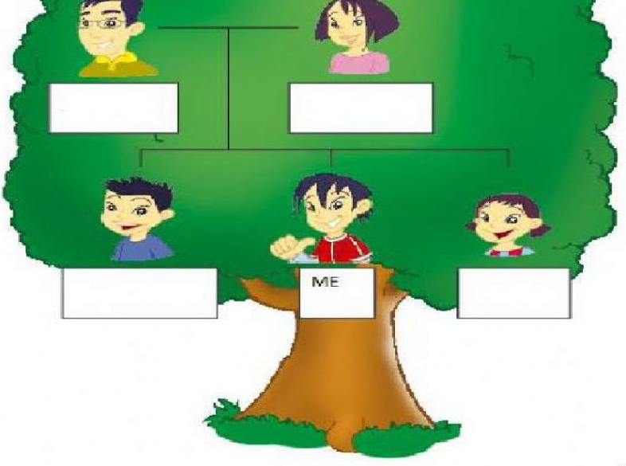

Dad
Sister
Brother
Mum

Question Five: ( 6 points)
Look and Match

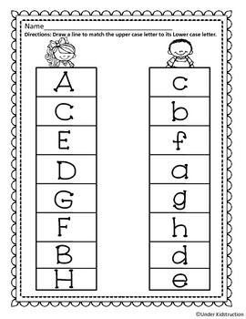

Teacher : Ghada Abu Salah

